Why feed Grit to poultry?

I am constantly amazed at the amount of poultry growers that don’t realized the importance of Grit. Grit is required by types of poultry and fowl, from parakeets to ostrich. All of them have a gizzard to grind their feed. I feel the commercialized feed companies and commercial poultry grower have lulled us into believing grit is not necessary. Why would they think way? The commercial poultry industry and feed manufactures have gone to a pelleted feed. Grit doesn’t work in a pellet making machine – pellet mill. The granite grit would increase the wear of the machinery and cost of manufacturing. So, they make feed that is pulverized into very fine powder. Then they process it through a pellet mill to make either pellets or crumbles. They feel the pulverized feed takes away the need for grit. The pellet dissolves or breaks down into fine particle feed in the digestive tract. It is believed that this is properly digested. For the most part they are correct.

Let’s look at grit this way, the chicken was created with a gizzard. The gizzard is a very dense muscular gland that is for grinding grains, forage, insects, or whatever the chicken finds to eat in nature. How does it work? The the chicken forages most of the day for whatever they can find that looks or taste good. But they are always looking for small stone to feed the gizzard at the same time. Anyone ever wonder why they commonly see wild birds along roadsides in the morning and evening? They are finding grit. Grit that is essential for proper food processing into digestible sized particles. Below are pictures of a pastured turkey liver unopened and same opened to show the amount of grit in comparison to feed and forage. Grit is Essential!!!

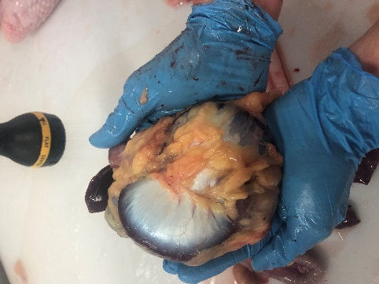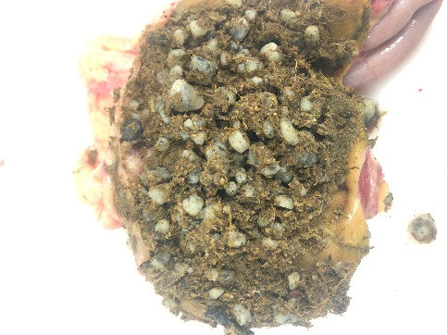

What size grit and when to use it?

**Starter Grower Layer/Developer Turkey Grower Turkey Finisher**

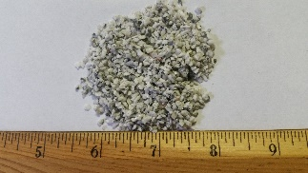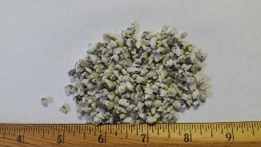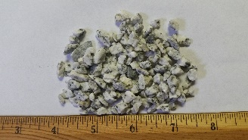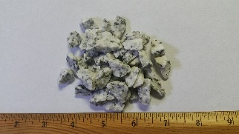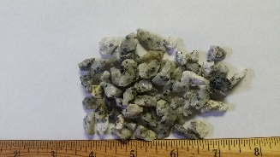

**Age day 1 – 3 weeks Weeks 4 – 8 Week 9 – end Week 12 – 16 Week 17 – end**

Grit has secondary benefits. With ample access to the correct size grit birds will not host internal parasites at harmful levels. The parasites just can’t tolerate rough stone particles sliding through the digestive tract. Internal parasites are part of the digestive tract Eco-system. Having zero parasites is actually as bad as having too many. The gizzard contracting and relaxing is tied to many of the metabolic systems. With plenty of grit and coarse feed, whole grains, and forage will stimulate the gizzard to contract and release more often. This will benefit the overall metabolism and improve feed efficiency. Typically feed efficiency increase by 5% to 10%. Want to know if your poultry need grit? Gather some fresh droppings, spread them out on a flat surface with a putty knife and look for undigested feed particles, grains, etc.

Think of Grit in this way, Grit is the equivalence of teeth for humans! Digesting food would be much more difficult without teeth to first grind our food. I am a huge proponent of grit! Almost to the point that I feel it is cruel and inhumane to raise any type of poultry without offering grit to them. Yes, they can live without grit. But, they will live better with grit!